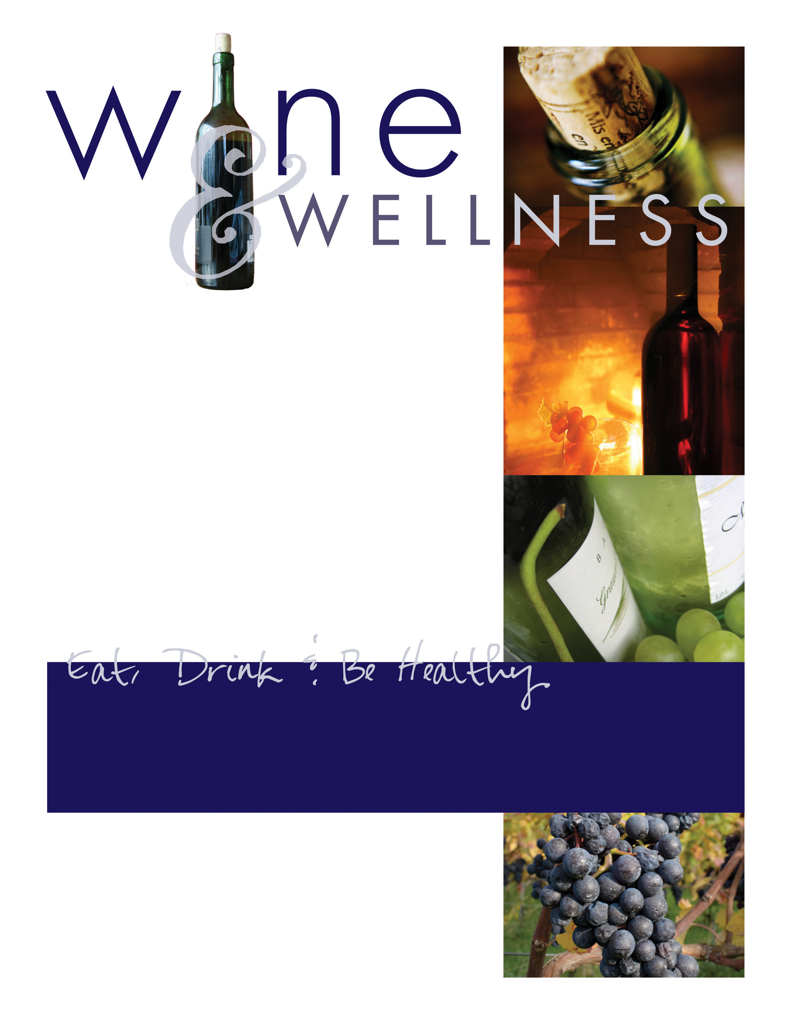

See the research at:
www.yourjuiceplus.com
If you had the opportunity to learn how to reduce:
• Your best friend’s risk of CANCER…
• Your spouse’s risk of HEART DISEASE…
• Your child’s risk of DIABETES…
• Your parent’s risk of ALZHEIMER’S…
• Your own risk of all DEGENERATIVE DISEASES…
Wouldn’t you want to know how?
Come learn about disease prevention!
Bring a friend or family member. Have fun, relax
and learn to get healthier together!
Wednesday, June 2nd @ 7:00 pm
Hosted by YOUR NAME • YOUR ADDRESS, Sanford, NC 27322
RSVP: 910/555-1234 or yourmail@gmail.com

Sponsored by Juice Plus+
“The next best thing to fruits and vegetables.”

