What can I expect from taking
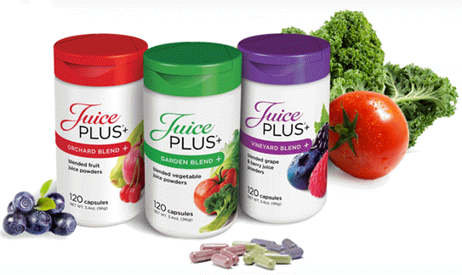
The next best thing to fruits and vegetables
JUICE PLUS+

Every individual is uniquely different and may or may not experience a variety of effects.

Some will have an increase of energy in the first few days, while for others it may be a very gradual increase over months.

Below are some of the benefits reported by those taking Juice Plus+ consistently:
- Less colds and flu
- Increased desire for fruits and vegetables
- Stronger and healthier skin, hair and nails, and gums
- Improvement in a variety of health problems and symptoms
- Increased energy levels
- Better, deeper sleep
- Better or more frequent bowel movements
- Quicker recovery from exercise

If none of the above occur, this can be quite normal as well. It takes about four months to get positive changes in most cases. The real effect of Juice Plus+ cannot be seen or felt; this is protection against oxidative, age-related and degenerative health problems, which happen very slowly over a long time. PREVENTION IS KEY!

We all need at least 9-13 servings of fresh, raw, vine-ripened fruits and vegetables per day for this protection. We need the antioxidants and phytochemicals from fruits and vegetables daily, but in our fast-paced society we miss out on eating anywhere near enough.

If we did without sleep for a day or two, we would feel no real significant effects, but poor sleep over months would certainly make us feel worse. If every day our body cells are being damaged due to oxidation (the major cause of degenerative diseases) and we are not protecting it, what is the logical outcome? – DISEASE.

Juice Plus+ will slow down the aging process and greatly reduce your chance of having degenerative health problems, but needs to be taken regularly (daily). It is not a medication or a food replacement, but a whole food supplement. Do not expect miracle cures, but think of it as your health insurance. This protection WILL HAPPEN even if you do not feel any noticeable improvement in your health.

Juice Plus+ is the most well researched and scientifically tested nutritional product in history. We do (and pay for) so many negative things that damage our health, so for health’s sake, do something positive and preventative. It is much harder to repair something that is already broken than to prevent it from breaking in the first place. You have available a nutritional product that offers real protection at lowering the risk of degenerative disease – TAKE IT.
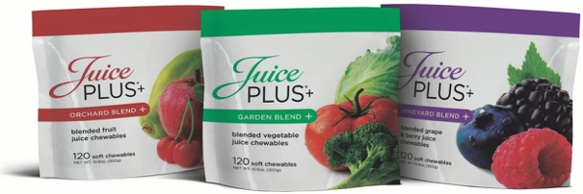
An excerpt from The F-Balance
by Mark Van Etten, ND, DA.
Name – email – phone

