WHY I RECOMMEND JUICE PLUS+

- Juice Plus+ is an easy and affordable way to get 30 fruits, vegetables are berries into your family’s diet every day, improving your nutritional status quickly.

- Juice Plus+ bridges the gap between poor, average, or good nutrition and SUPERIOR nutrition.

- Juice Plus+ is backed by indisputable research (see summary enclosed). Proven to support your immune system: a healthier immune system means less illness and disease, fewer missed work and school days, and better overall health.

- Juice Plus+ has been proven to increase the antioxidant levels in your blood, protecting your cells from damage. Less cell damage means less chance of cancer, and less premature aging and chronic degenerative disease.

- Juice Plus+ has been proven to decrease free radicals in your blood. This is huge! Free radicals are detrimental to your health and are the basic cause of all degenerative diseases including cancer, alzheimers, heart disease, diabetes, etc. The only way to fight free radical accumulation is by eating fruits and vegetables each day. Juice Plus+ is the next best thing, to ensure you’re getting enough protection!

- Juice Plus+ is FOOD. The body understands whole food nutrition… Juice Plus+ has a food label, and is better absorbed by your body than fragmented vitamin supplements.

- Juice Plus+ is the most thoroughly researched nutritional product and the number one selling encapsulated nutritional supplement in the world.
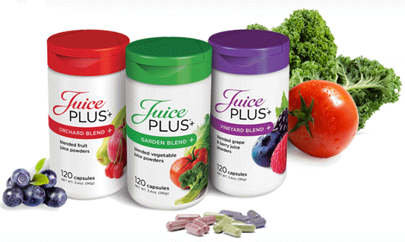
BOTTOM LINE:

I take Juice Plus+, my family takes it, and my patients who
receive regular chiropractic care and take Juice Plus+ are
the ones who are sick the least and are the most healthy.
I believe Juice Plus+ is the best foundational nutritional
product available today. ~ Dr. Ross
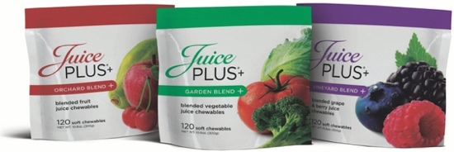

Why don’t you give it a try for you and your family, and begin to receive the protection it has been proven to give? It’s the best health insurance policy I know!

Ask me how to get your children’s Juice Plus+ FREE!

carrots, parsley, beets, kale, broccoli, cabbage, spinach, tomato.
apple, orange, pineapple, cranberry, peach, acerola cherry, papaya.
bilberry, blackberry, black currant, blueberry, concord grape, cranberry, elderberry, raspberry, pomegranate

