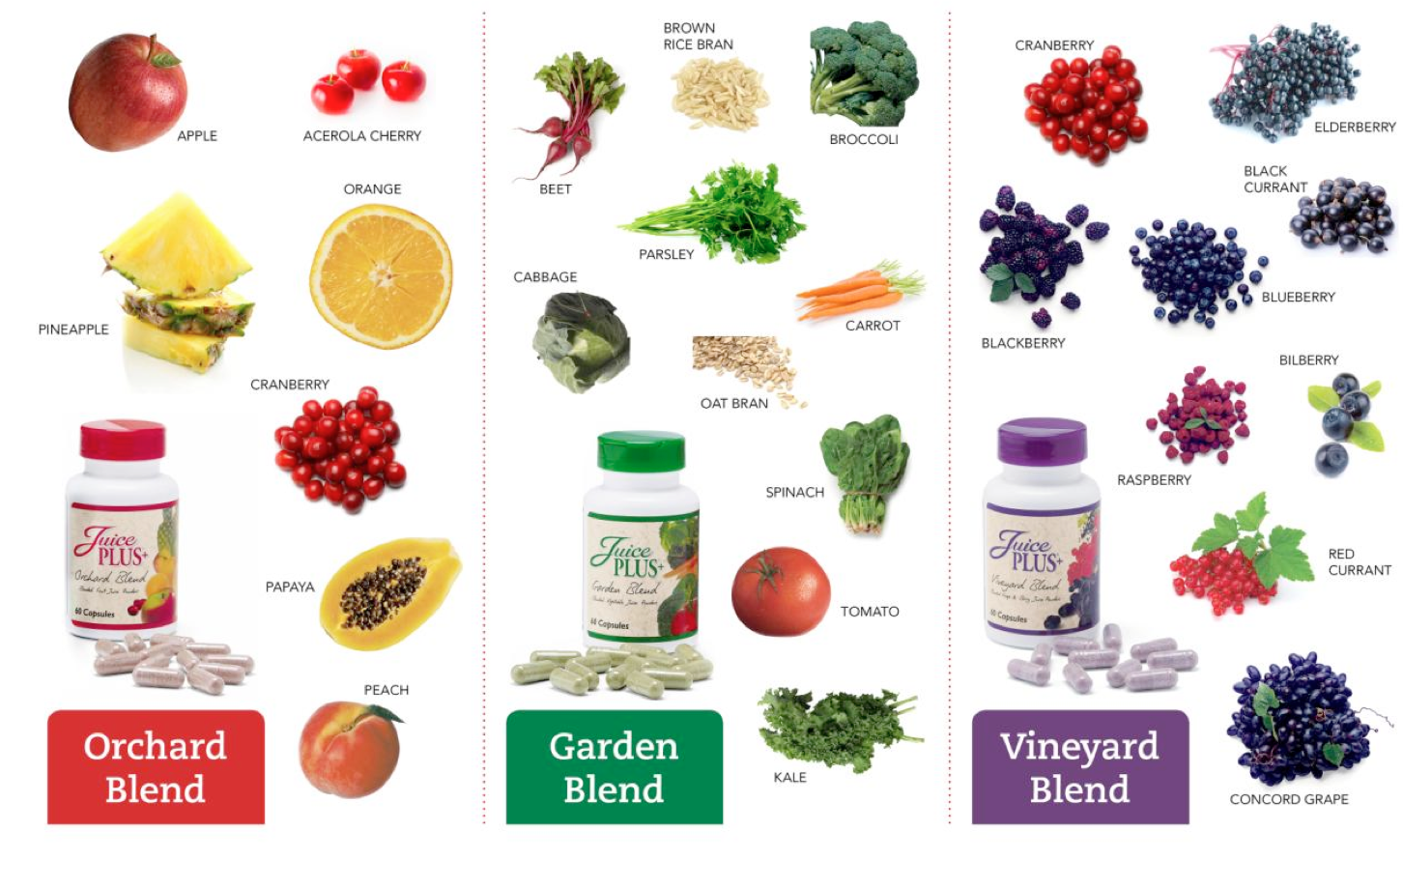

Join us for a Garden Party
March XX 6:00 PM
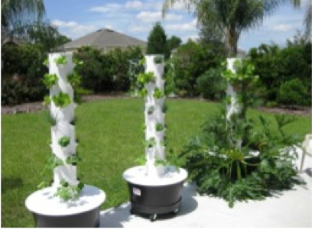
Hydroponic, aeroponic, no weeding, no tilling, no kneeling, no dirt! The Tower Garden is a plug and play vertical garden. No need to have a green thumb! It comes with everything you need to start growing. It’s easy to assemble and fun for the whole family. Watch your food grow from seed to an abundant harvest in just 3-4 short weeks. Join the “Locavore Movement” and grow your own Farmer’s Market from your own deck, balcony, poolside or rooftop patio!

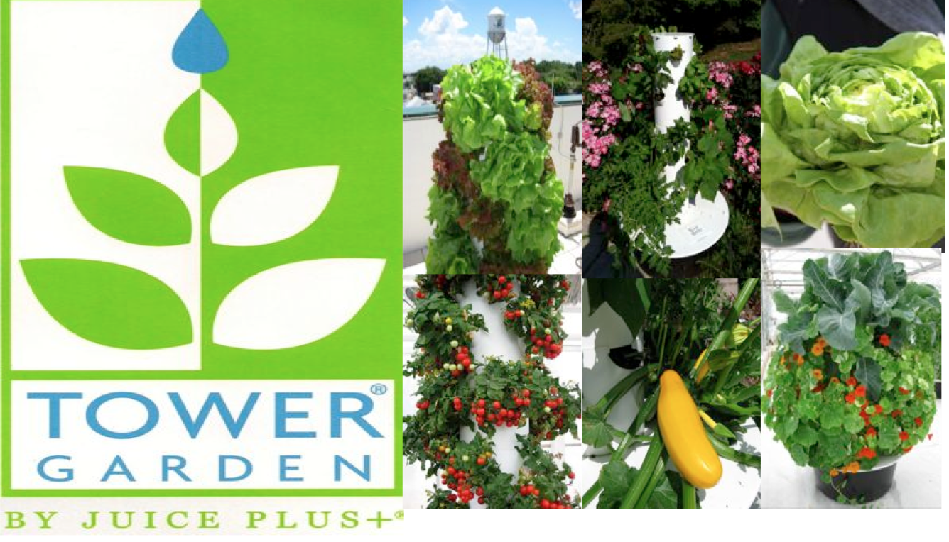
Come see, learn and taste right from the Tower Garden!
We’ll be serving delicious, healthy snacks!
Address here
RVSP Phone Number here

Check out our new website: www.towergarden.com and click on ABC News

Introducing the Tower Garden:

